**Report View**

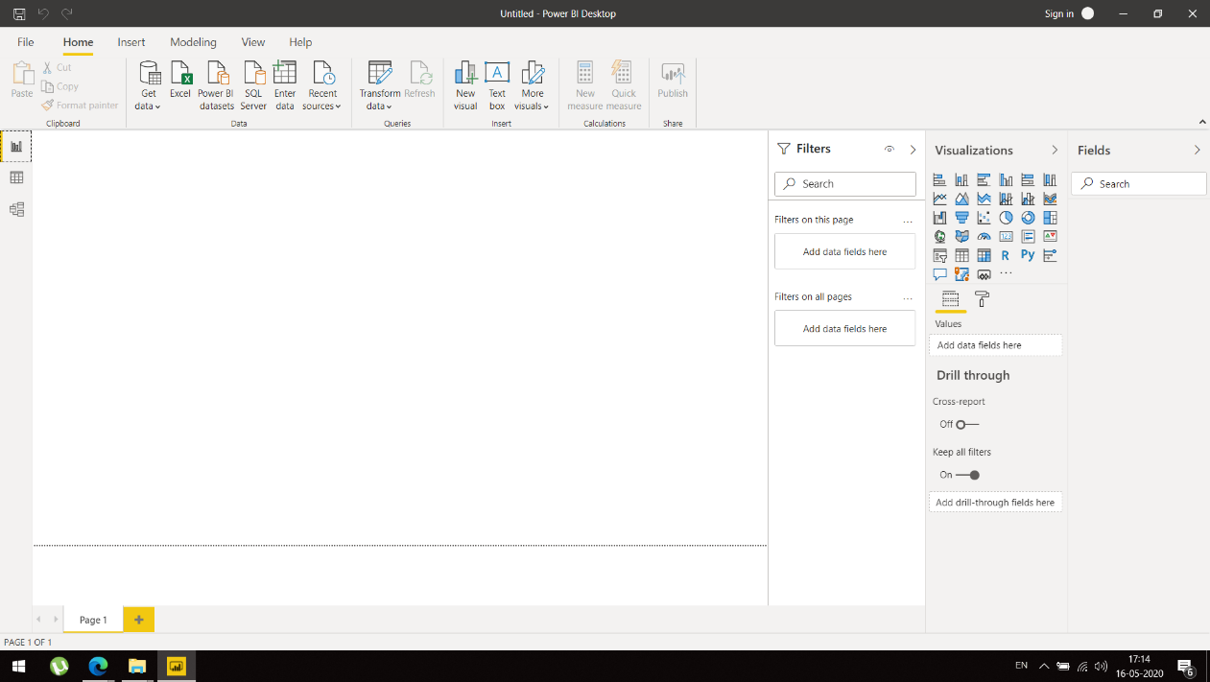

**Data View**

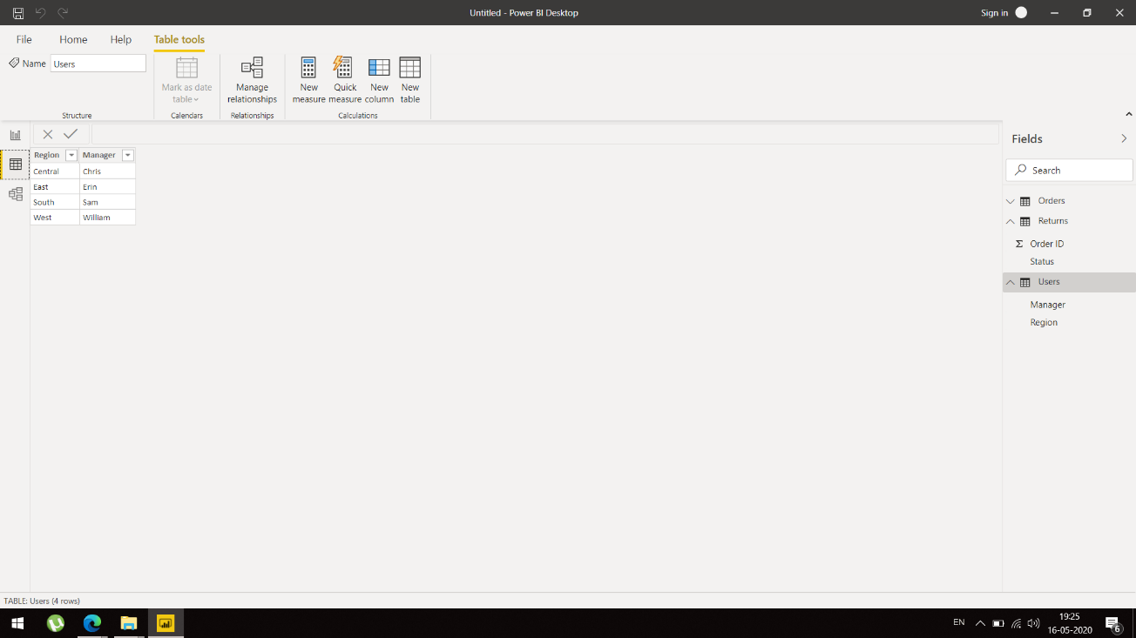

**Data View**

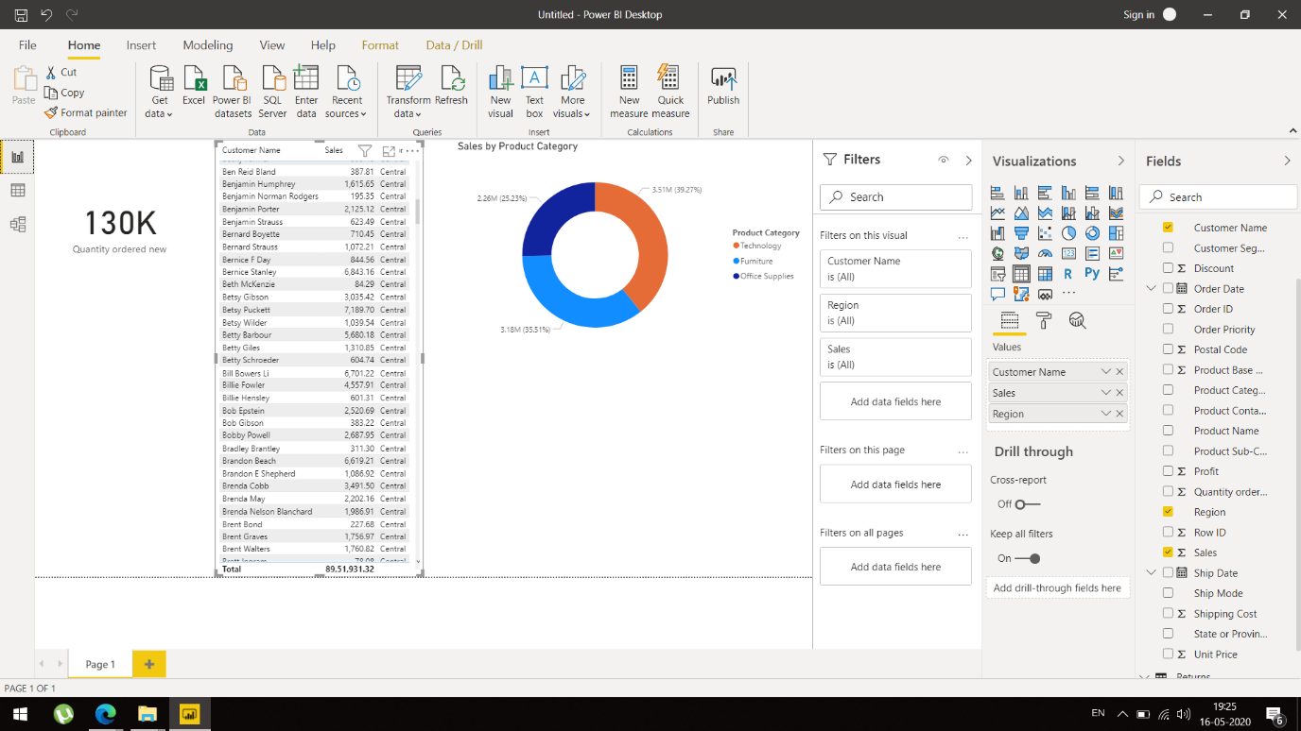

**Model View**

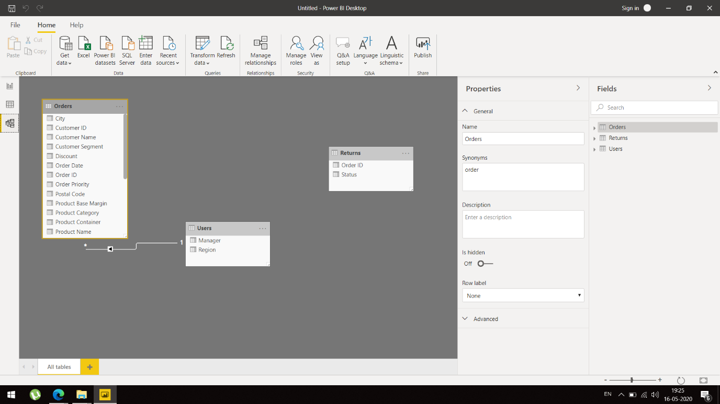

Power Query Editor

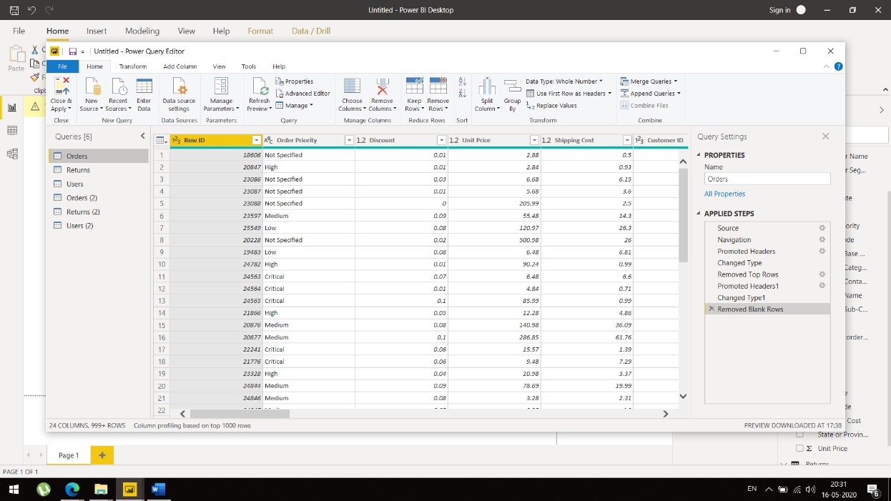

**Advance Editor**

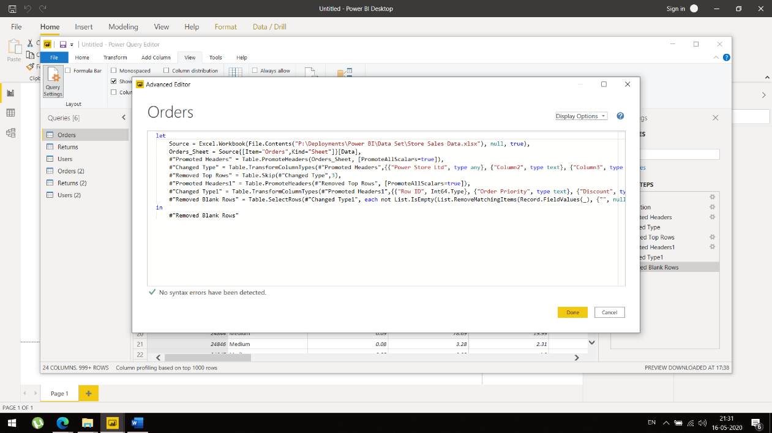

**Power BI Desktop** is available for free which can be downloaded from Microsoft website or windows store.

**Power BI Pro** is subscription based which can be bought for free for a limited time and costs 699 rupees per month.

**Power BI Premium** which is an Enterprise BIis annual subscription based service with dedicated compute and resources. It costs around 3,30,190 rupees per year and may vary based on resources utilized.